DAWOOD UNIVERISTY OF ENGINEERING AND
TECHNOLOGY
DEPARTMENT COMPUTER SYSTEM ENGINEERING
PROJECT REPORT


Predicting Hospital Readmission for Diabetic Patients

Name: Uzair Arif Jokhio (22F-CS-17)
Course: Data Science and Analytics (CSE-4304R)
Teacher Name: Engr. Farhan Ahmed

Contents

1. Introduction 2
1.1. Problem statement 2
1.2. Objective 2
2. Data Collection and Preprocessing 2
2.1. Data Description 2
2.2. Data Cleaning and Handling Missing Values 2
2.3. Feature Engineering 2
2.4. Exploratory Data Analysis (EDA) and Trends 3
3. Applied Algorithm and Methodology 4
3.1. Choosing the Model 4
3.2. Measure of Success 4
3.3. Experimental Setup 4
4. Experimental result and performance evaluation 4
4.1. Model Comparison 4
4.1.1. Analysis of Result 5
4.2. Tuning The model 5
4.3. Results 6
5. Discussion of Finding and limitation 6
5.1. What was Found 6
5.2. Managing Conflicts 6
5.3. Limitations 7
6. Conclusion 7

Introduction

Problem statement
Hospital readmission is defined as a patient returning to the hospital within 30 days of discharge. This is a problem for diabetic patients, coming back soon means they didn’t get enough care after leaving. This costs hospital a lot of money and is bad for patients’ health. The goal is to build a model that can predict which patients are at high risk of returning.

Objective
Our main goal is to build a classification model using “Diabetes 130-US Hospitals" dataset. This model will guess if a patient will be readmitted within 30 days.

Data Collection and Preprocessing

Data Description
Data is collected from UCI Machine Learning Repository. It covers 10 years (1999–2008) of care at 130 US hospitals. It covers 101,766 patients record with 50 different features.

Data Cleaning and Handling Missing Values
- Dropping columns of weight with (97% missing), payer code (40% missing), medical specialty (47% missing) and examide, citoglipton, encounter_id, patient_nbr because they weren’t help in classification.
- Removing patients that were dead because they cannot be readmitted.

Feature Engineering
- Age group: the data gave us a range like “[60-70]”, I changed these into simple number so it can be easier of model to compute like “60-70” turn into 65.
- Categories to number: for race and gender we used “one hot encoding”.
- Removing useless feature: I removed rare medicine that were rarely used, and kept 20 important features such as number_inpatient, time_in_hospital, and insulin usage.

Exploratory Data Analysis (EDA) and Trends
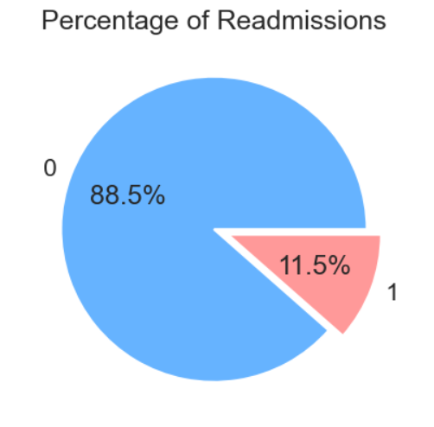
- The Imbalance Problem: Our first graph showed that only 11.5% of patients are readmitted. This tell us that "Accuracy” would be a bad metric because a lazy model could just guess "No" every time and be 89% correct.

- The Age Trend: looked at readmissions by age group. The risk is lowest for young adults but spikes for patients between 70 and 80 years old. This suggests that older patients need more careful monitoring after discharge.
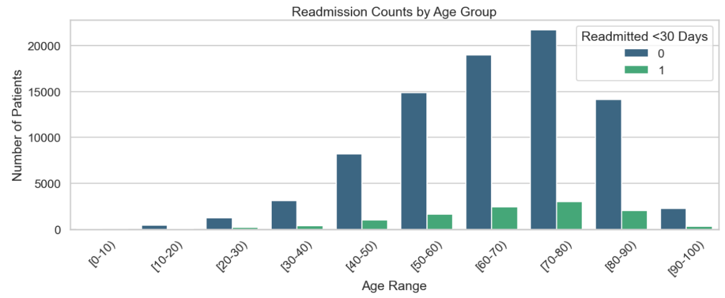

- The Prior Visits: Patients who had visited the hospital multiple times in the previous year were twice as likely to be readmitted compared to those with no recent visits.
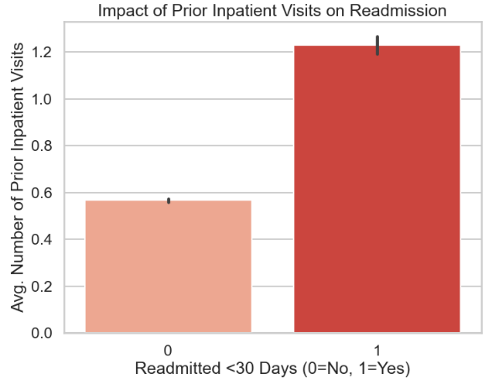

Applied Algorithm and Methodology

Choosing the Model
- Random Forest Classifier: A strong model that uses many "decision trees" to find complex patterns.
- Gradient Boosting: A smart model that learns from its own mistakes to improve accuracy.
- Logistic Regression: A simpler mathematical model. We chose this one because it is easy to understand and lets us adjust the "sensitivity" to catch more sick patients.

Measure of Success
Most patients do not come back to the hospital only ~11 do, because if this Accuracy is not a good measurement of success. The model could say No for everybody and still be accurate. Instead, we will focus on Recall. This measure shows how many sick patients were correctly found. Missing a sick patient is very dangerous.

Experimental Setup
Split the data into 80% training and 20% testing data and used a special setting called class_weight = “balance” to tell the model to pay extra attention on minority class.\

Experimental result and performance evaluation

4.1. Model Comparison
Tested three models and compared their results side-by-side. The table below shows the clear trade-off we faced
Model | Accuracy | F1-Score | Recall | Precision | ROC-AUC
Logistic Regression | 0.675 | 0.269 | 0.520 | 0.182 | 0.658
Random Forest | 0.885 | 0.016 | 0.008 | 0.474 | 0.639
Gradient Boosting | 0.884 | 0.019 | 0.010 | 0.382 | 0.666

Analysis of Result
- Logistic Regression (LR): LR had a lower Accuracy (67.5%) but a higher Recall (52%). This model successfully identified more than half of the at-risk patients. Even though it makes more mistakes on healthy people, by prioritizing the detection of sick patients.
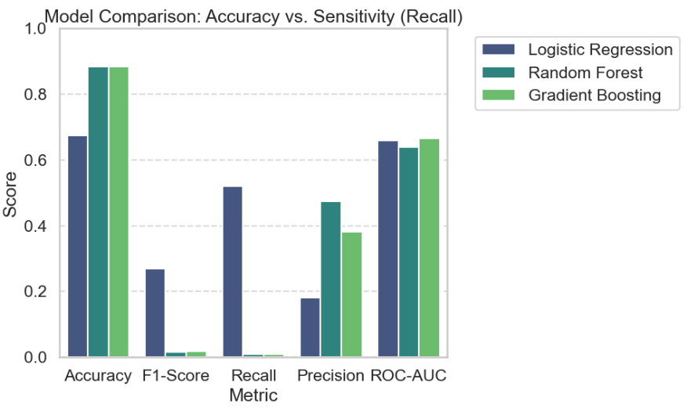
- Random Forest and Gradient Boosting: These models have achieved very high Accuracy (88.5%). However, the Recall is near zero (0.008 and 0.010). they have achieved high accuracy by sampling guessing “No readmission” for every patient. In a hospital, these models would be useless because they would send 99% of high-risk patients home without help.
Because of this we selected Logistic Regression for final Model

Tuning The model
Picked Logistic Regression. We fine-tuned its settings (using Grid Search) and changed the "decision threshold." This means we told the model: "If there is even a medium chance the patient is sick, mark them as high-risk.
Best Parameters Found: {'C': 0.01, 'solver': 'lbfgs'}
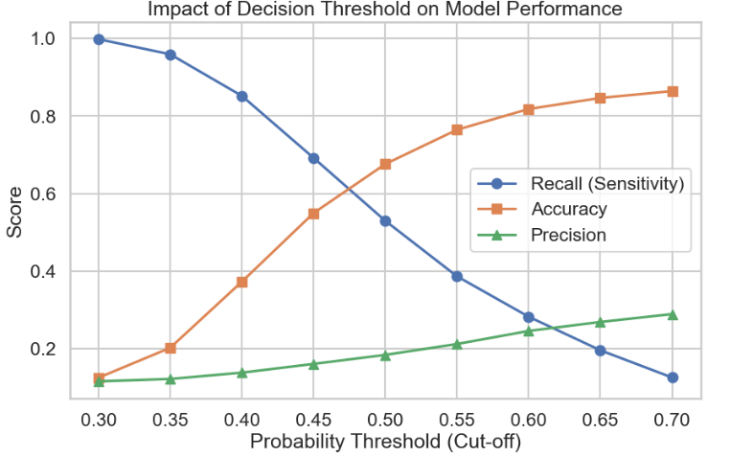
- At a low threshold (0.30), we catch 100% of sick patients, but accuracy is terrible (10%) because we flag everyone.
- At a high threshold (0.70), accuracy is good (85%), but we miss almost all sick patients (Recall < 15%).
Decision: selected a threshold of 50%, at this spot we Recall of ~53% and an Accuracy of ~67%.

Results
After applying this tuning, our final logistic regression gave these results:
Threshold | Recall | Accuracy | Precision
0.50 | 0.530 | 0.676 | 0.18

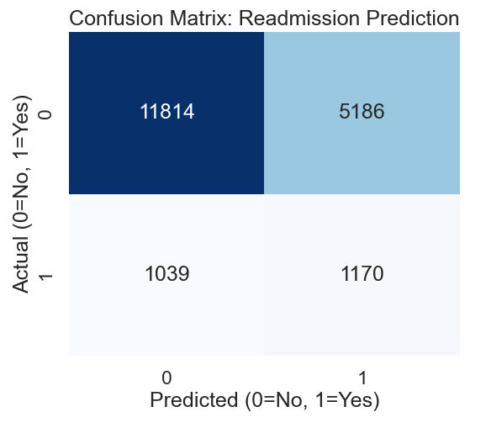
Confusion Matrix
The model successfully found 1,170 high-risk patients (True Positives). It also raised 5,186 False Alarms (False Positives). In healthcare, a false alarm is okay (a nurse just checks on a healthy person), but missing a sick person is dangerous

Discussion of Finding and limitation

What was Found
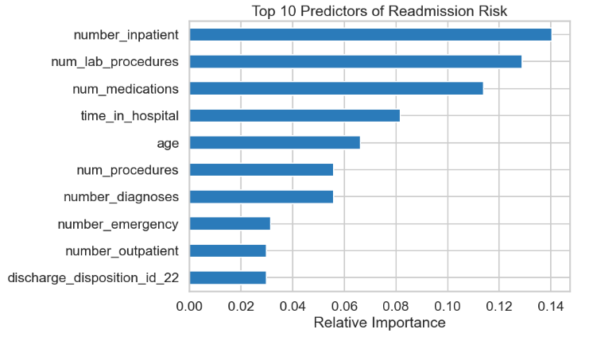

Our analysis showed that number_inpatient was the most important feature for the model. This means people who go to hospital often are likely to go again.

Managing Conflicts
A big problem was to balance Precision vs Recall. High precision mean fewer false alarm, High Recall mean fewer missed sick people. We choose high recall. the cost of missing a sick patient is much higher than the cost of an extra check-up.

Limitations
- Missing Details: We only had administrative data. We didn't have vital signs or social details, which affect health a lot.
- False Alarms: Because we wanted to catch every sick person, the model flags a lot of healthy people too. Doctors might get tired of checking so many alerts.

Conclusion
This project successfully built a data-driven tool to predict diabetes readmissions. By trading some accuracy for better sensitivity, we built a "safety-first" model. We increased the detection rate from <1% (in Random Forest) to 53% (in Logistic Regression).

